**Name** : Shantanu Shaligram Ingale

**Date** : 14 June 2024

**Assignment** : Maximum Value Code in Technology assigned

**Technology** : ASP .NET CORE (Web App MVC)

**Under Guidance :** Niranjan Aradhye Sir.

***PROBLEM DEFINITION***

Given is a matrix denoting a weighted table. Find a rectangle of sides of length at least 2, such that the minimum weight from the 4 corners of the rectangle is maximized. That is for the table ***A[N][M]***, find the maximum value of **MIN**(***A*[i1][j1]**, ***A*[i1][j2]**, ***A*[i2][j1]**, ***A*[i2][j2]**)such that 1 <= ***i1*** < ***i2*** <= ***N*** and 1 <= ***j1*** < ***j2*** <= ***M***.

***SOLUTION***

* Solution is created in Repository Pattern introduced in technology.
* Aims in solution is
  1. To take user input for *ROW* ,  *COLUMN* and *INPUT* for any test case.
  2. Generate Result and also save the record in database
* **MAIN LOGIC AND VIEW PAGE**

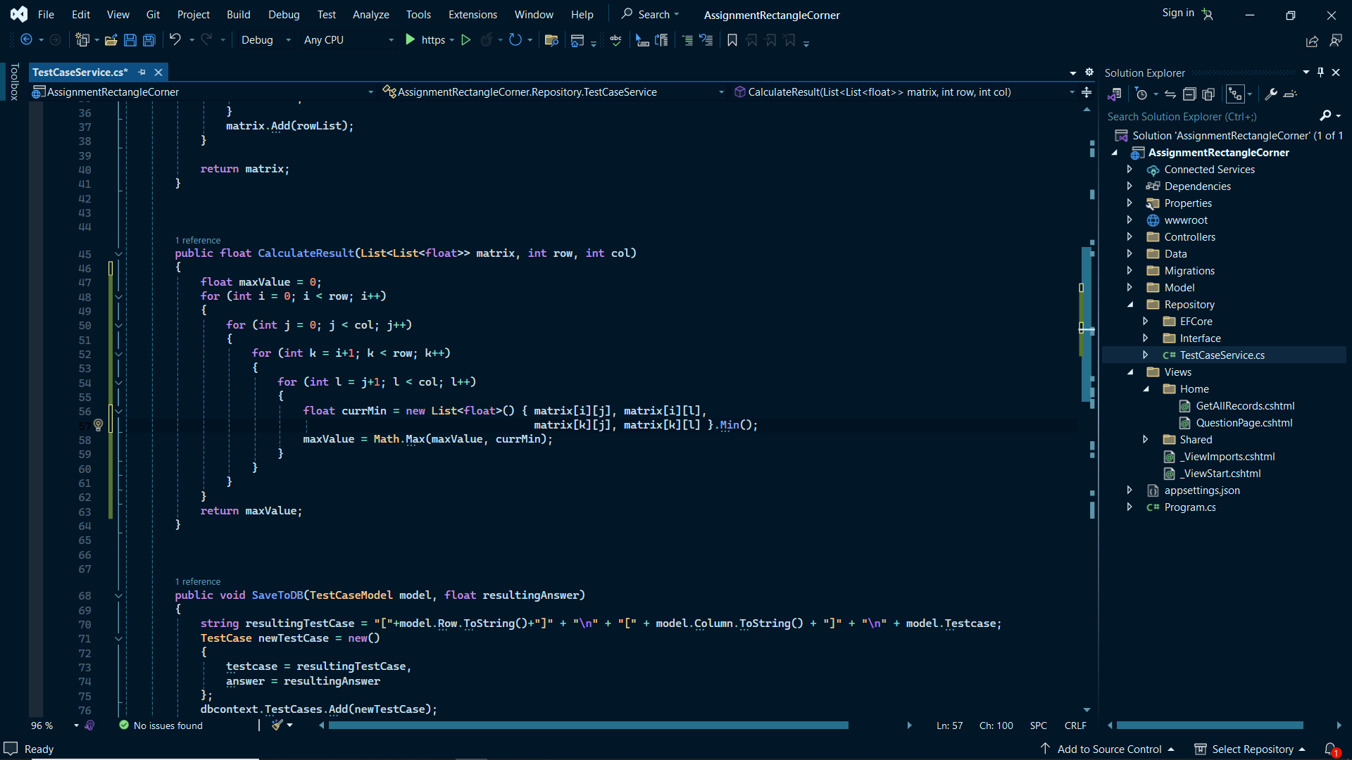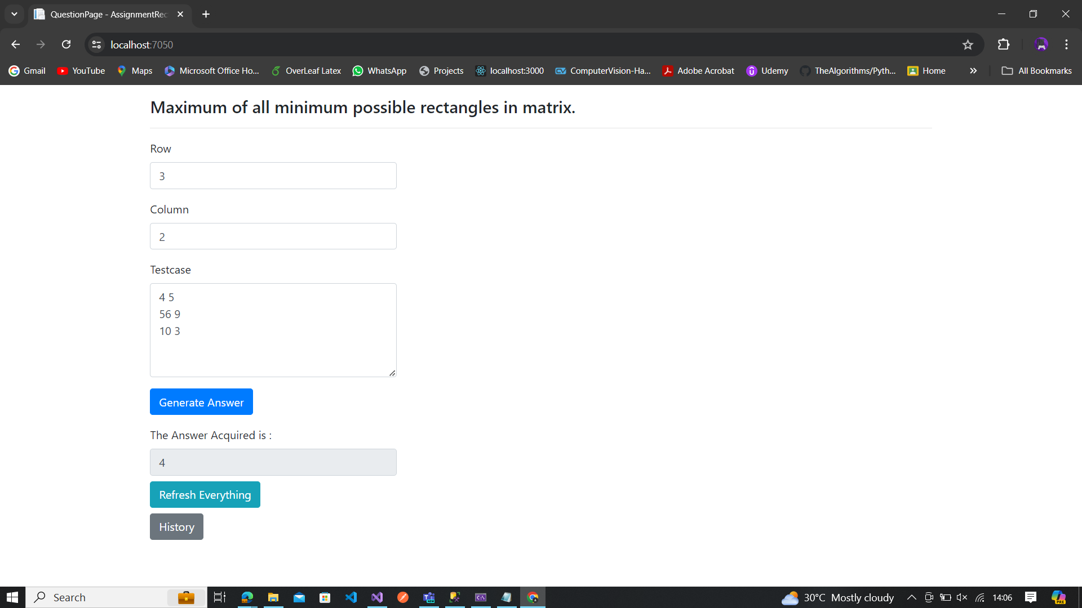

* **TEST CASES RESULTS AS HISTORY IN VIEW**

